

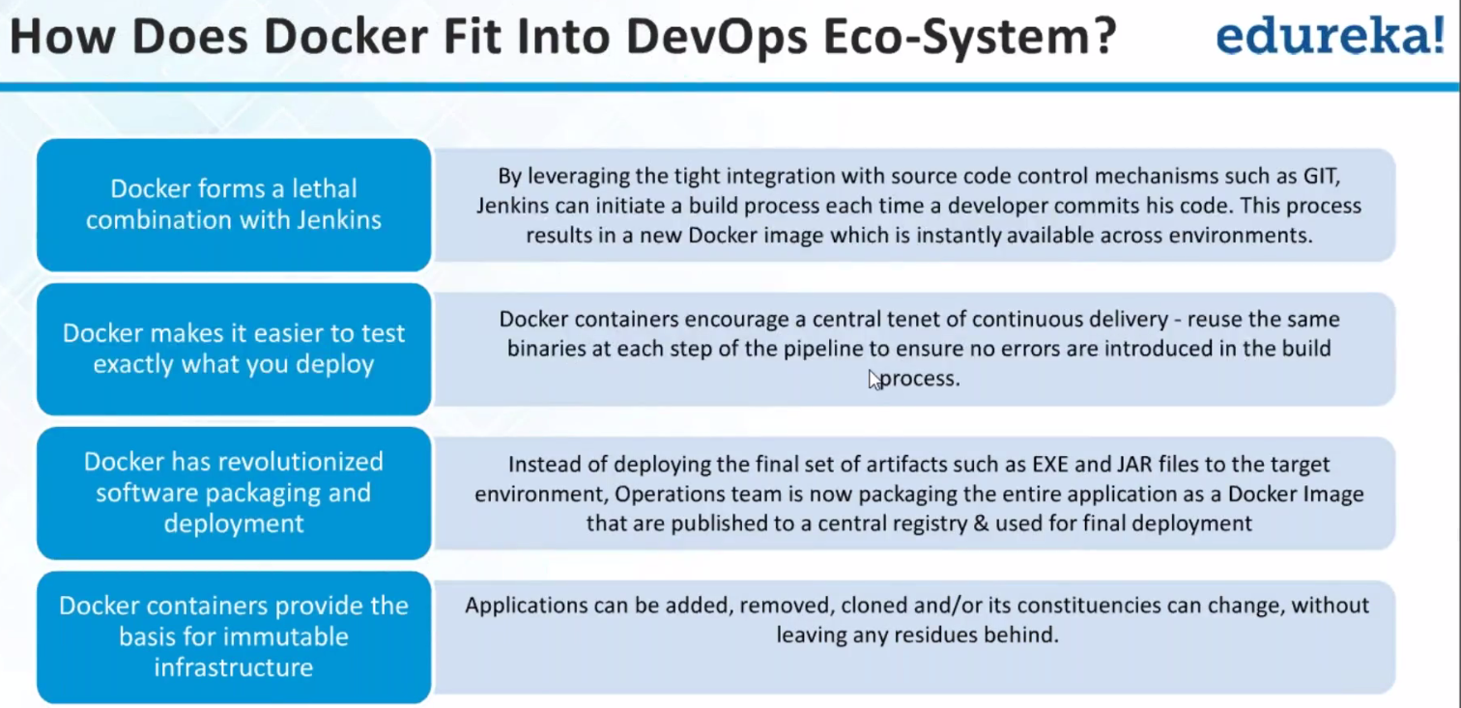

I want to supply oil, wheat, coffee to customers..

I make sure I transport all as a single whole.. Easiest way: Send oil seperatley.. wheat seperatley., coffee seperatley..

This is like Install tomcat, Install Jenkins, install Java, Install Maven and then install APP..

So, for realtime to run APP..I need Java, jenkins,..Why cant I ship at One go..

**We can do it easily. But how effectively we can ship??**

**Sol: It have everything installed…Just open and run it.. Vbox(vdi image have all s/w dependencies), docker..So it will work exactly the same..**

**1.) Whatever is required is packed as a single logical whole..-🡪containerizati**on.

2.) Let say I require java and then tomcat. If Java is already installed in 1 m/c..What happens??

Our assumptions are if java not installed.., install it..Tomcat not install it.

Also I want my APP not only to run on Centos .. But also on Ubuntu.

It can playback on any platform.

3.) Deploy and setup in no time.

Install blah blah blah..No need to know about java,tomcat

4.) Which version u want.. we can do

Tomcat 6 –ok.., Tomcat 7 –ok..,

5.) Download time for VBOX extremely large. Containers.. Extremely light weight.

Fully blown OS..Do we need Libre office---?? Gcc??----Only APP

Ps –aef | wc –l ??

6.) We can go back to versions back.. Provided Version control is there..

7.) Works in Dev..not in QA..Not in stage..

Some diff in Infra, config changes won’t be there….As consistent as possible.

If my QA is down, we can recreate new QA m/c same exactly day as before crash happened before day.

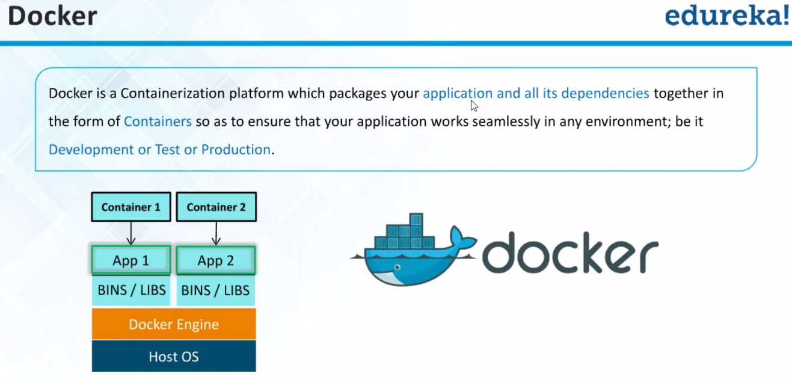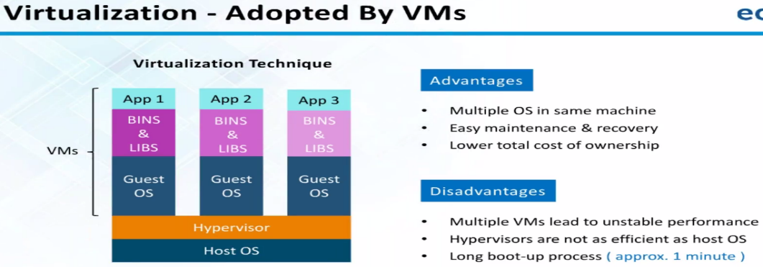

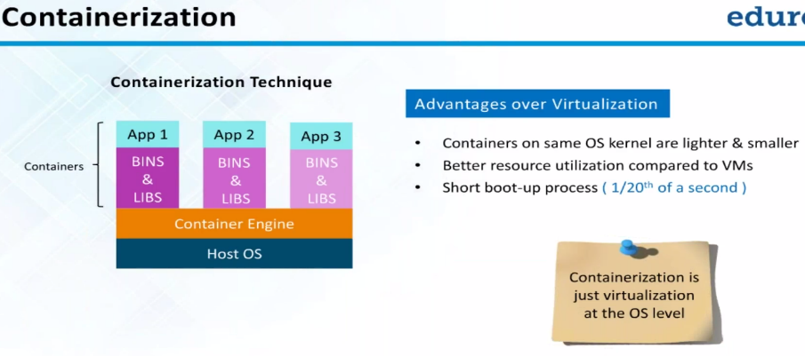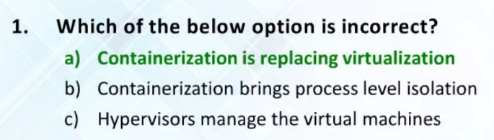

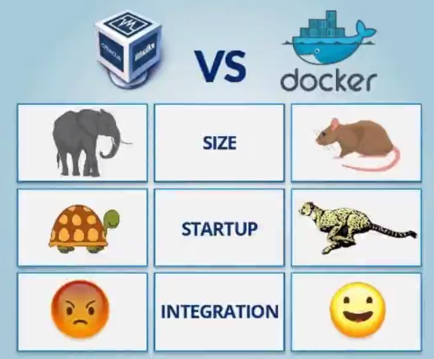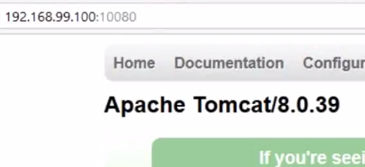

IP’s of containers:

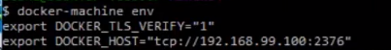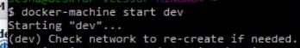--🡪101 IP

Memory is locked..

Memory is what APP. Is using..

No Windows images for docker.. But docker can run on windows.

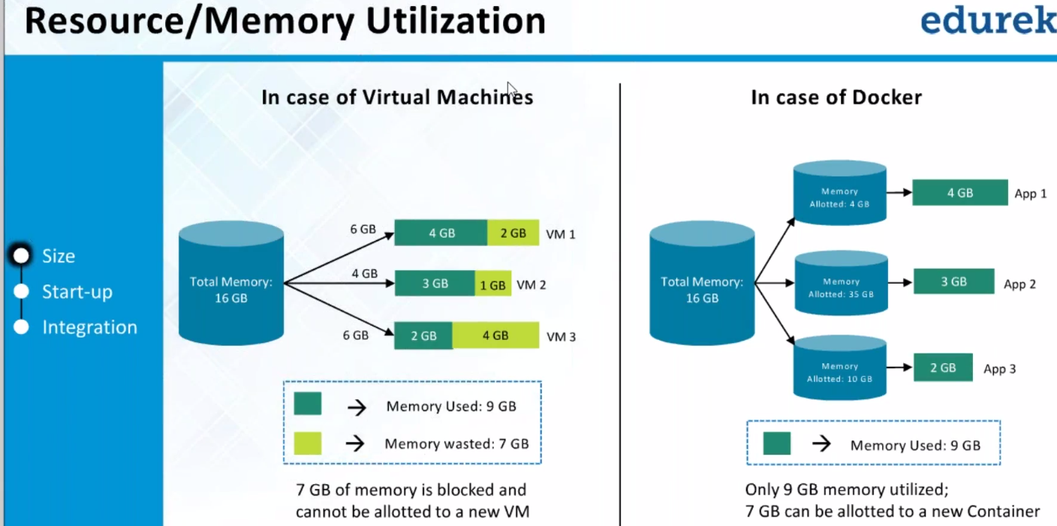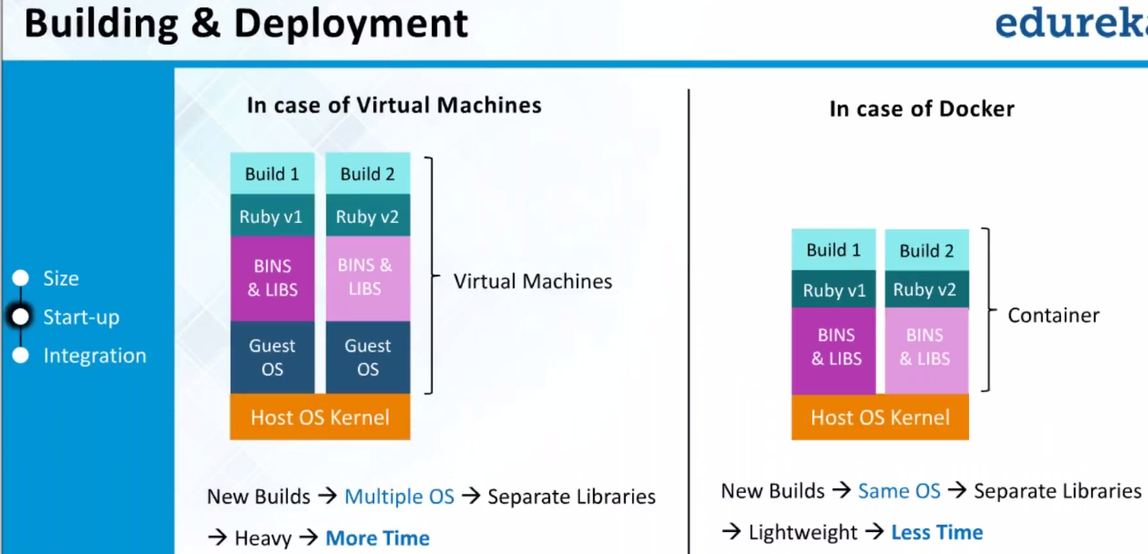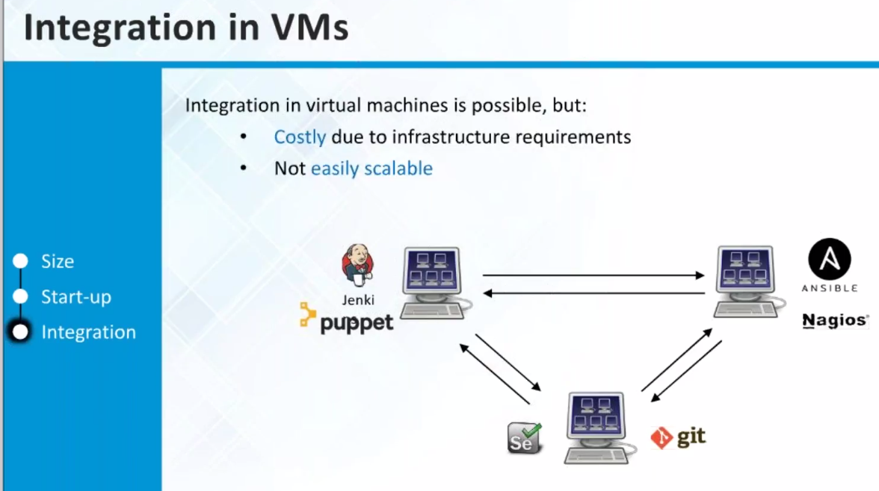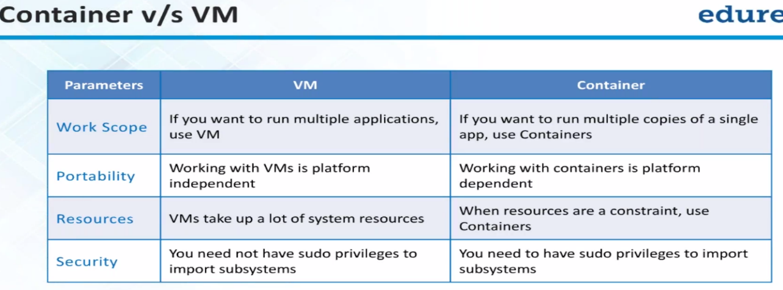 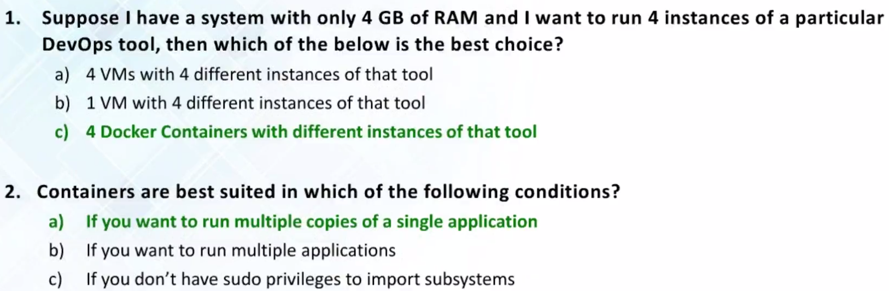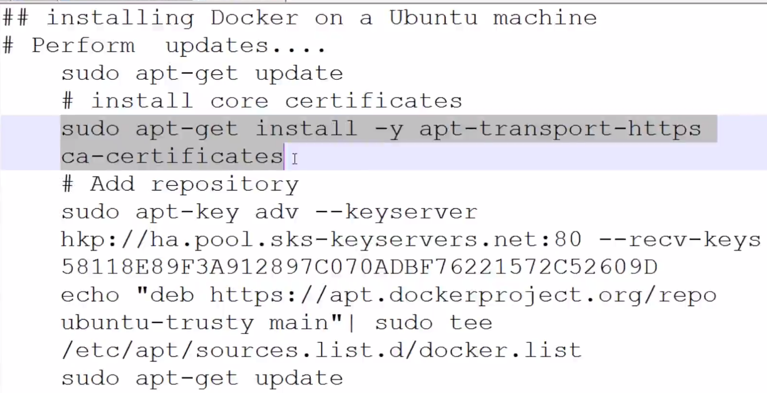

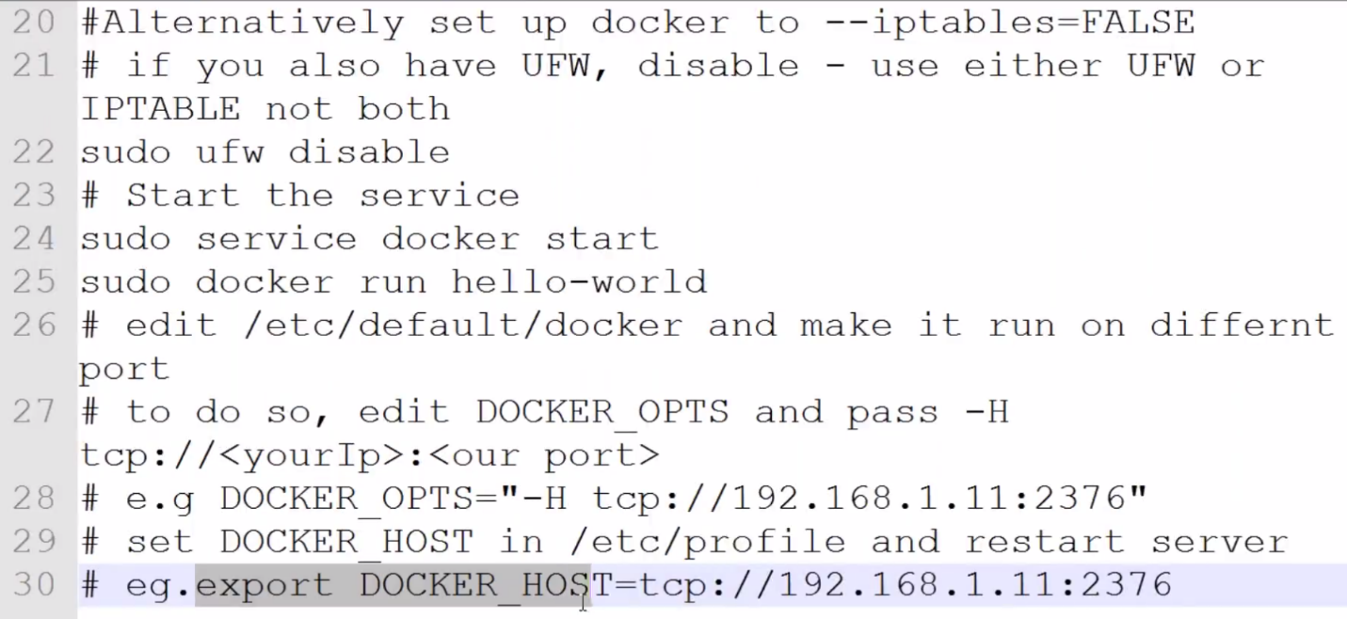

Latest SSL, HTTP certificates required for docker to coomunicate

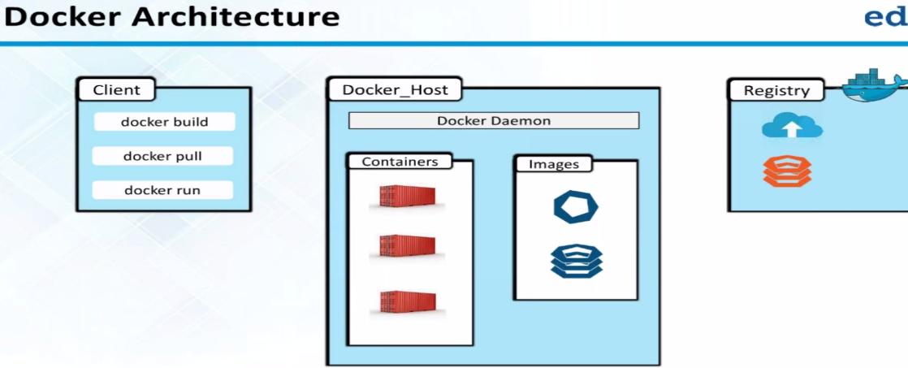 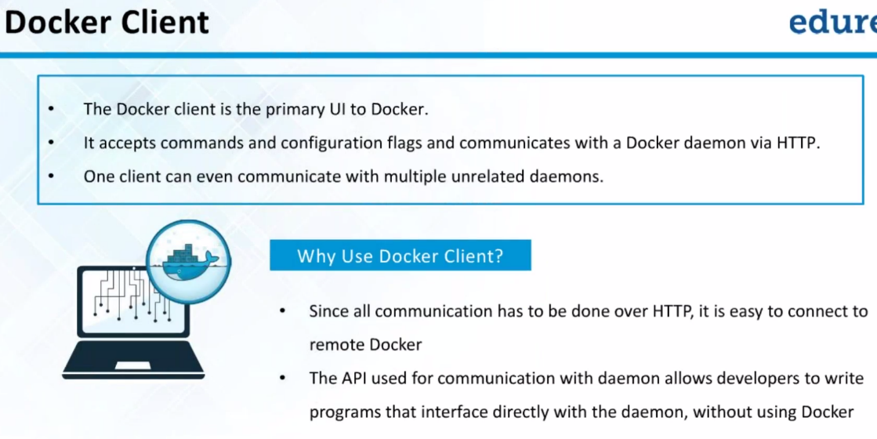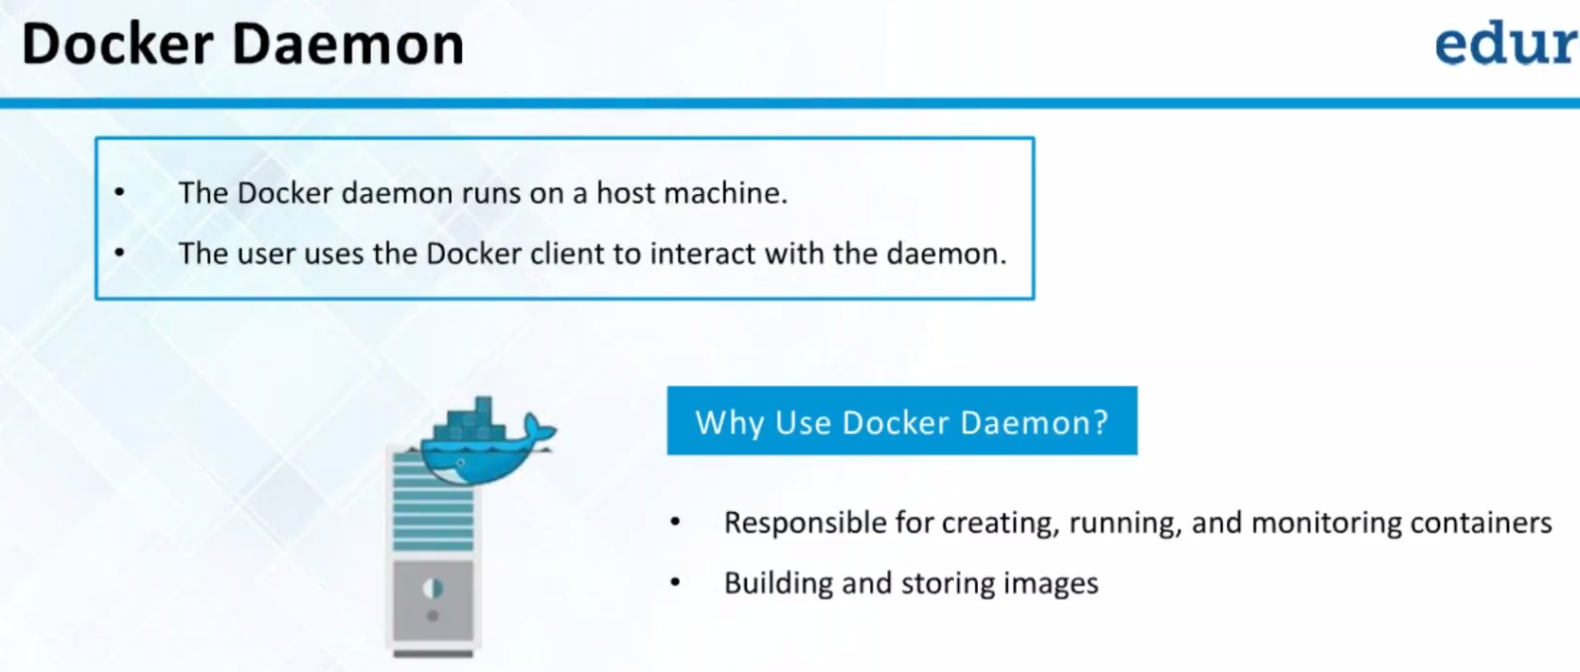

Docker daemon running on background.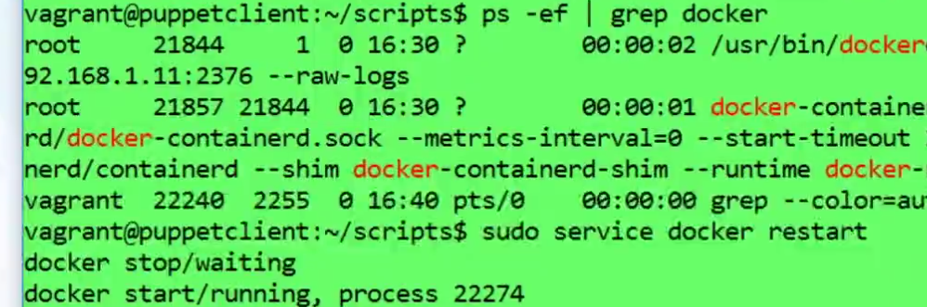

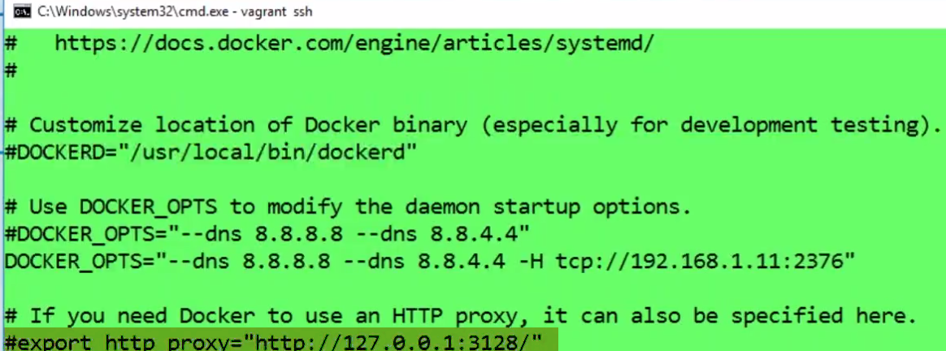

If we have HTTP proxy, and want docker and fetch all images..And we are behind proxy server.

We should uncomment it 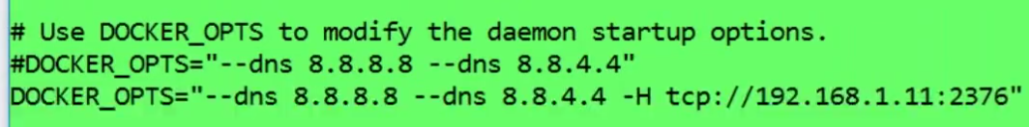

By default docker daemon runs and listens on Unix socket.

So everytime, we need to run daemon command, we have to change permsiion of socket so that

Non-superuser can access it or we have to say Unix socket doesn’t quite work well.

So instead we can use it on TCP/IP network.

One of biggest option is to specify: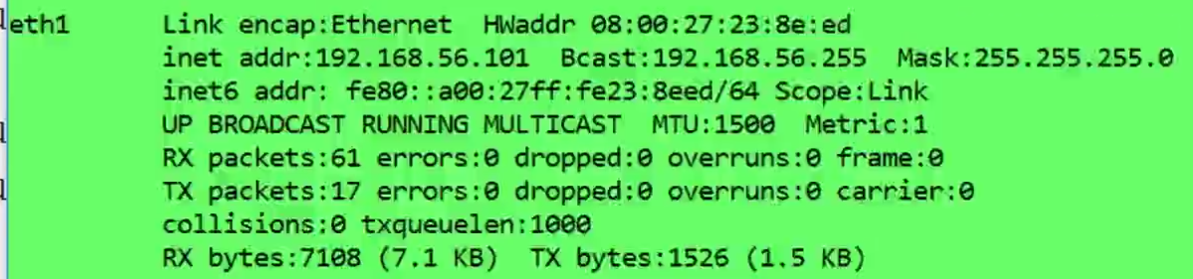

I want to listen on TCP/IP port, not on Unix socket..

-H ----> and then add it.either or

This is for starting daemon process.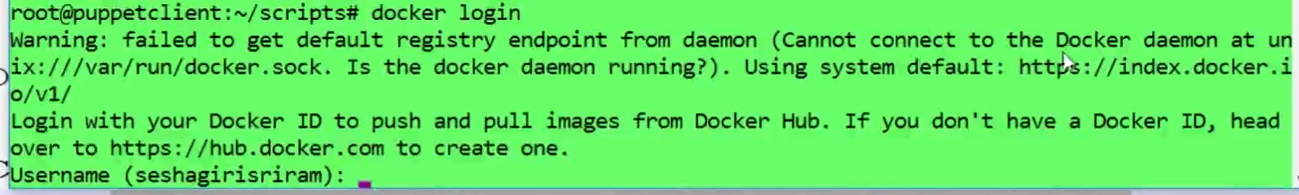

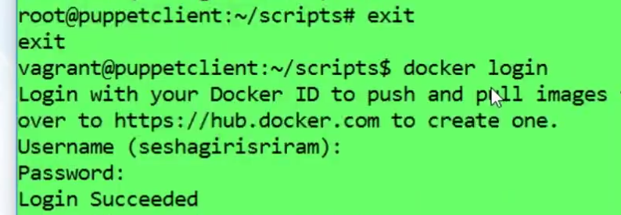

By default,clinet should be able to connect to daemon.

How does this worked??

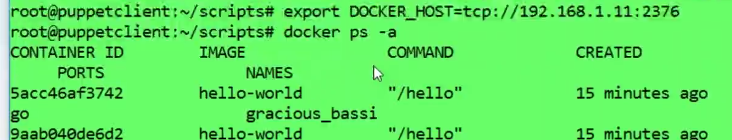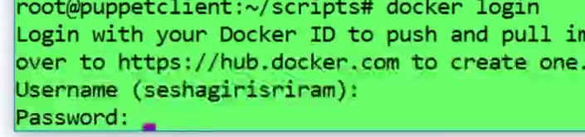

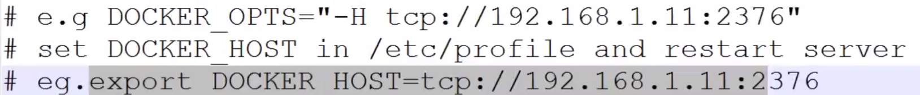

If DOCKER_OPTS is changed…Change DOCKER_HOST accordingly.. By default docker daemon runs and listens on Unix socket.

So everytime, we need to run daemon command, we have to change permsiion of socket so that

Non-superuser can access it or we have to say Unix socket doesn’t quite work well.

So instead we can use it on TCP/IP network.

**SOL:**

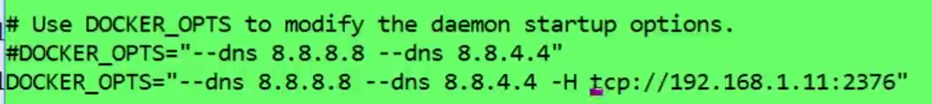

**DOCKER_OPTS is not an ENV.Variable.It’s an option we are passing to Daemon**

**LISTEN on TCP/IP.**

**Installing only Client:**

**Master: ( I can find images—templates)**

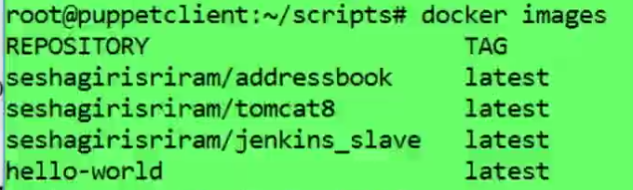

**Slave:**



**Connecting to remote docker-daemon**

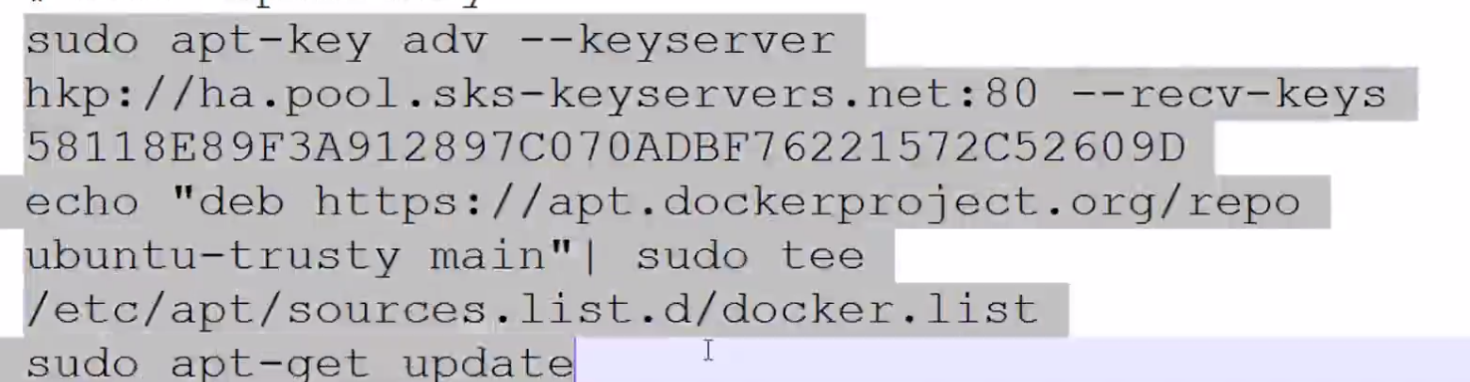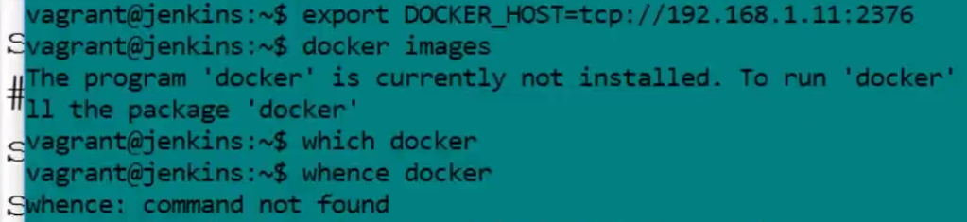



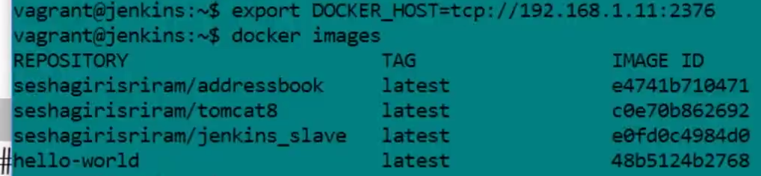

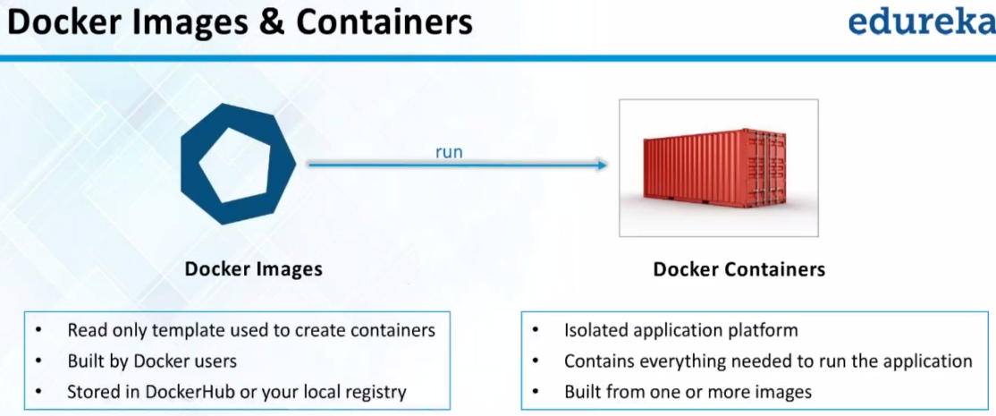

**Once image is created. It is read-only.**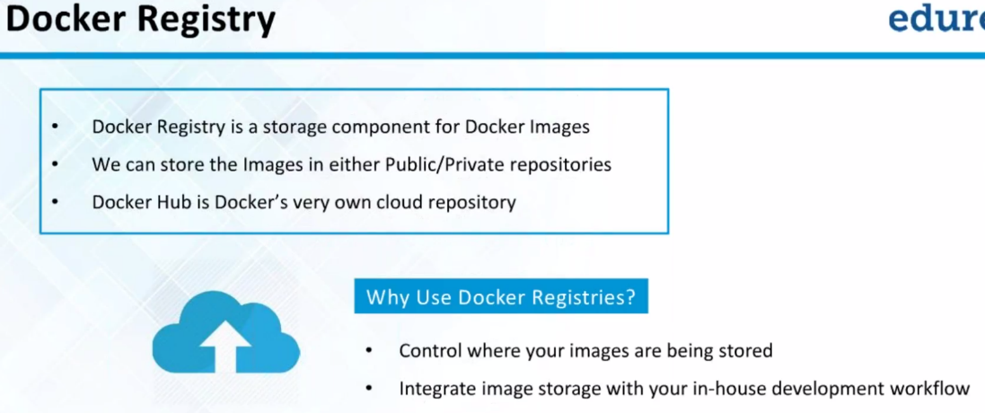

**If we want additional private repo🡪 pay for service**

**Let’s say I want to test old build#5. It already went to prod.But customer complains of not working..**

**One way: Get physical copy of code back or 2.) use Some s/W todo..**

**Instead, we can have it in your own public/private repo.. Anybody who wants to do it..**

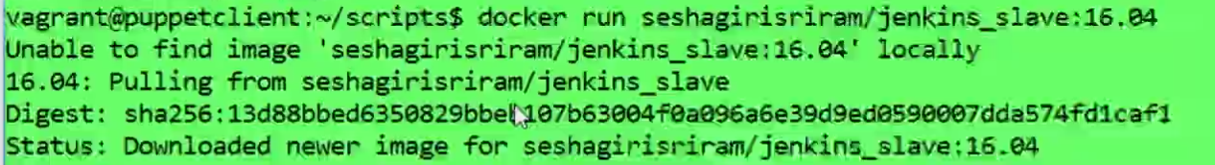

**Jenkins slave at version 16.04 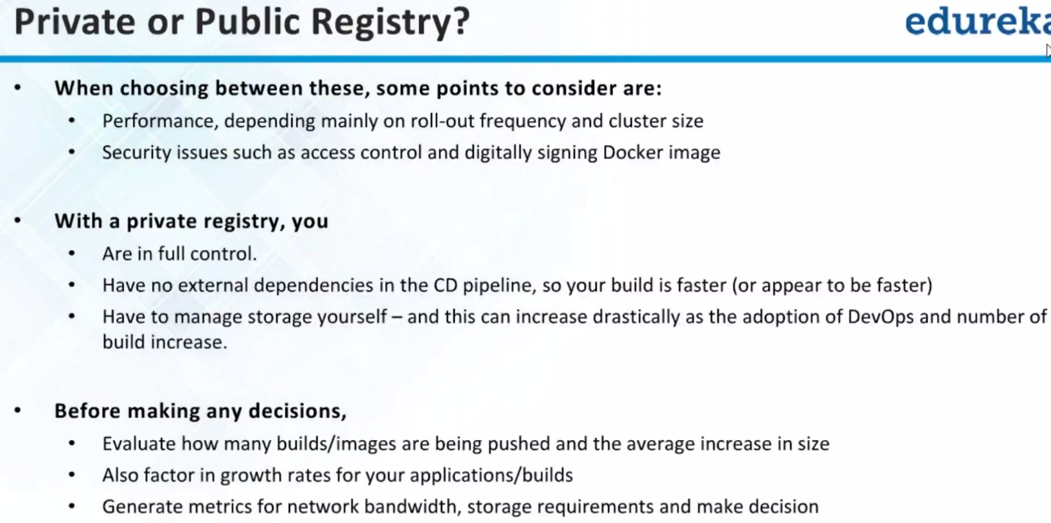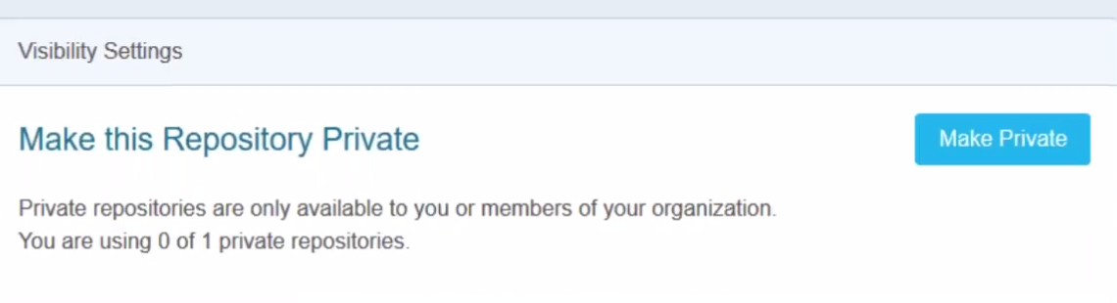You can have 1 private repo.. Additional we have to pay**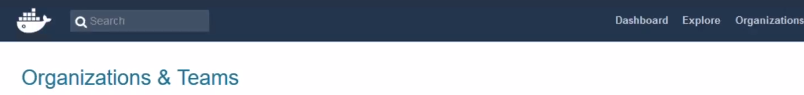

Under Organization, we have multiple teams working on it..

Create Org:

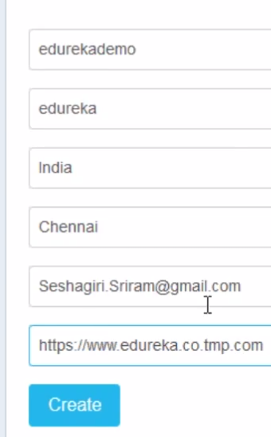

Who owns which repo:

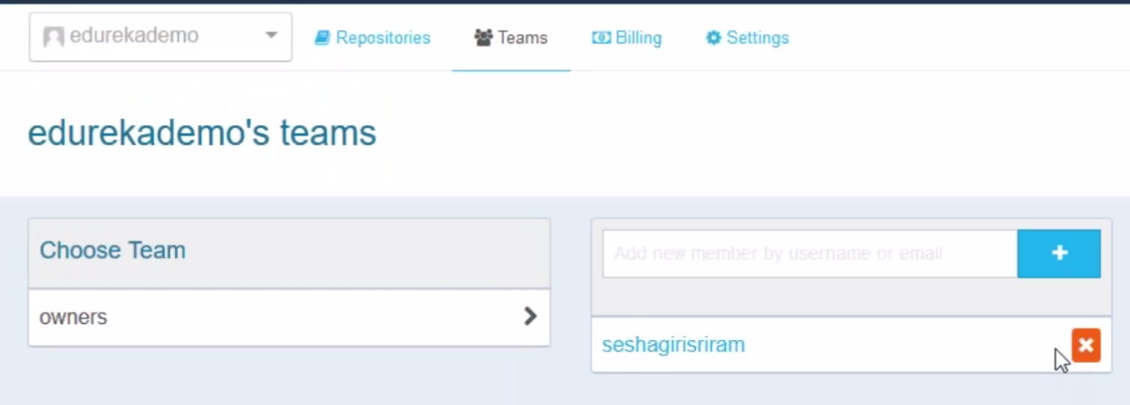

Can we use Nexus to store images?

We can store in Nexus.. But cannot pull it back.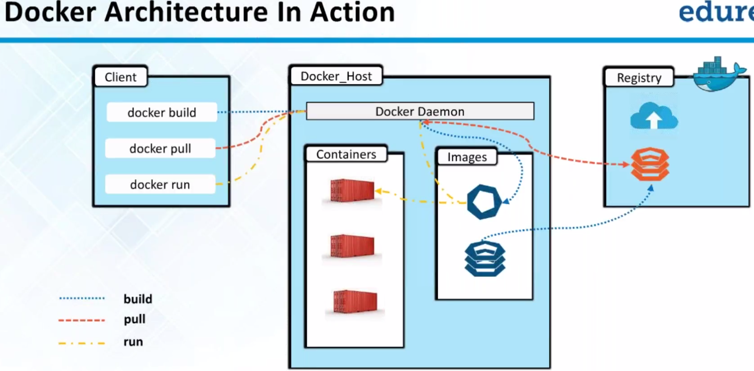

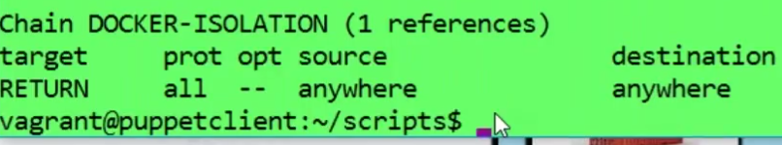

We can see DOCKER-ISOLATION. Initially when docker got setup .. It will also setup some firewall rules for you..It will allow client connection only from so and so m/c..Not from everybody..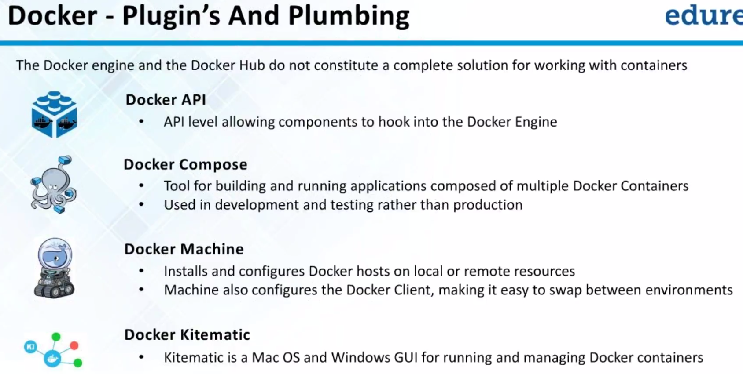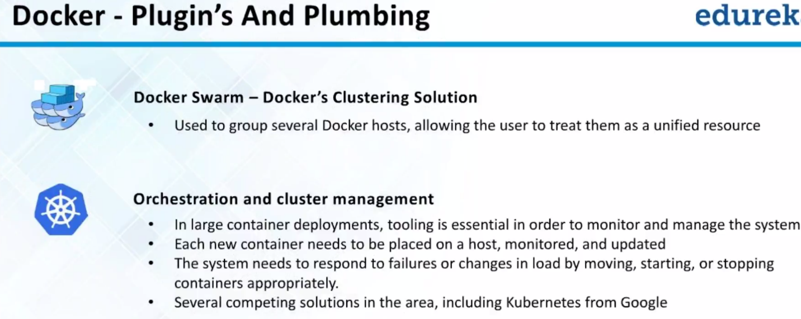

In prod, we will have multiple cluster of docker hosts..

Where is my docker running..Whether in A,B,C or D.

Instead we use Kubernetes or Docker swarm to manage these docker m/c as if one logical whole..

We will have more Docker hosts🡪 then load balancing🡪kubernetes/swarm..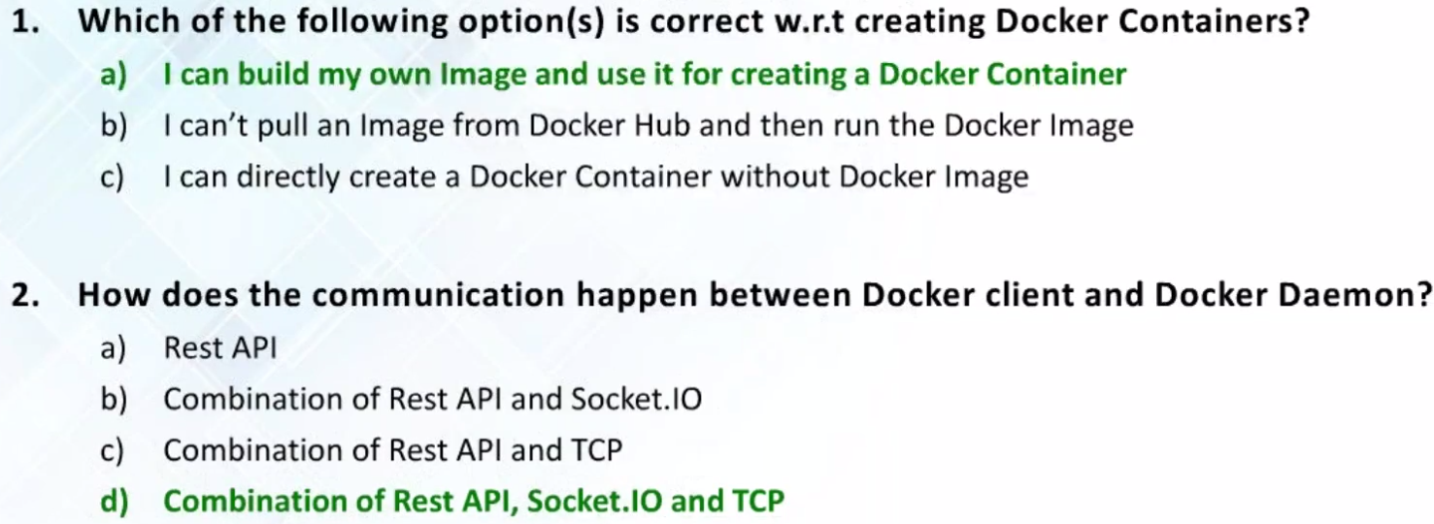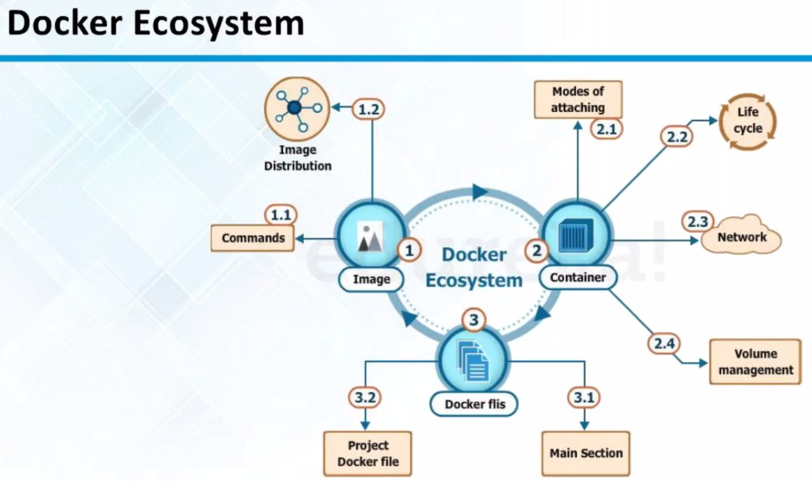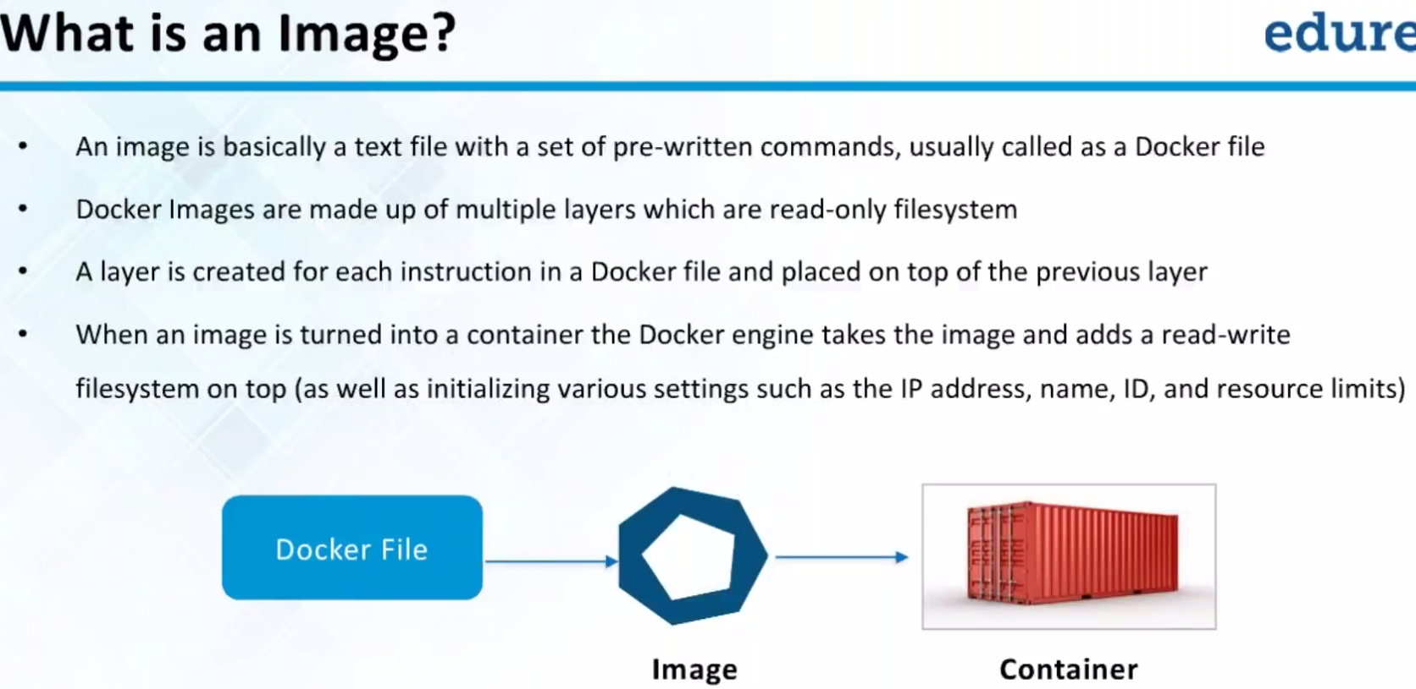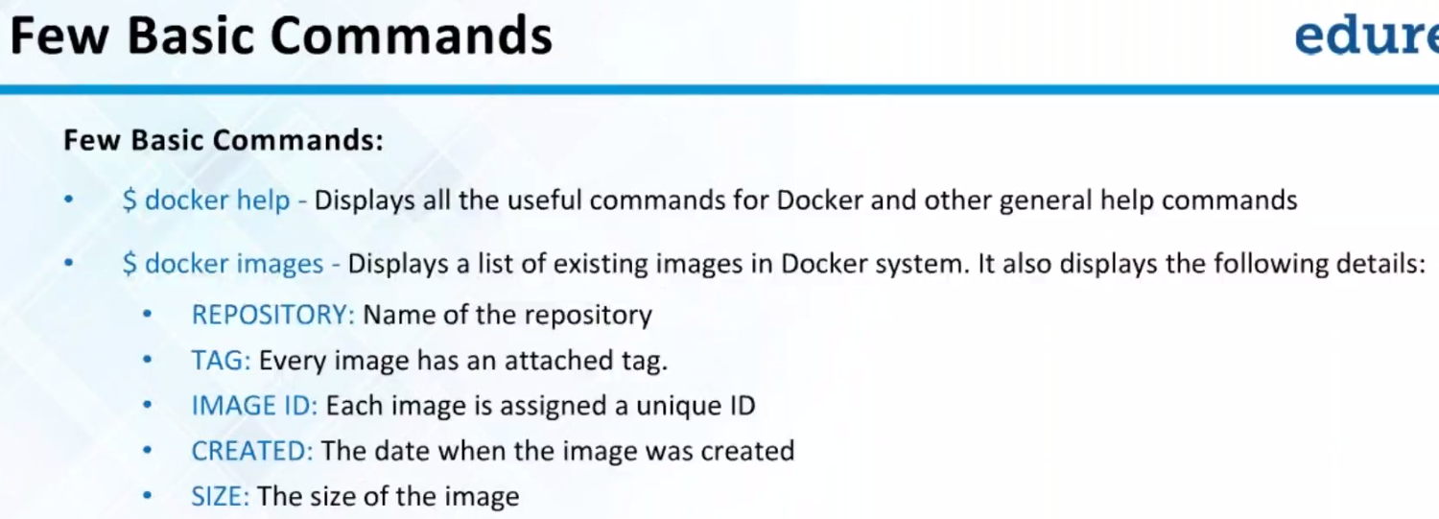

NOTE:: If we want to see every images..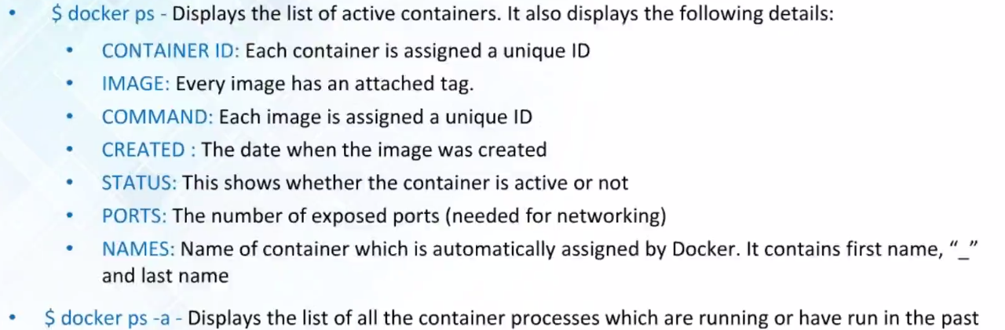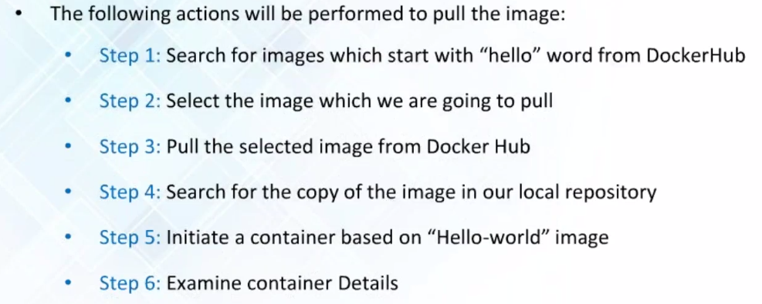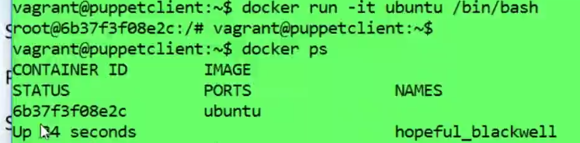

CTRL+P, CTRL+Q🡪 Run container without terminating..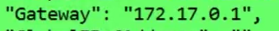🡪Docker inspect command (on windows)

On linux🡪 192.168.0.1

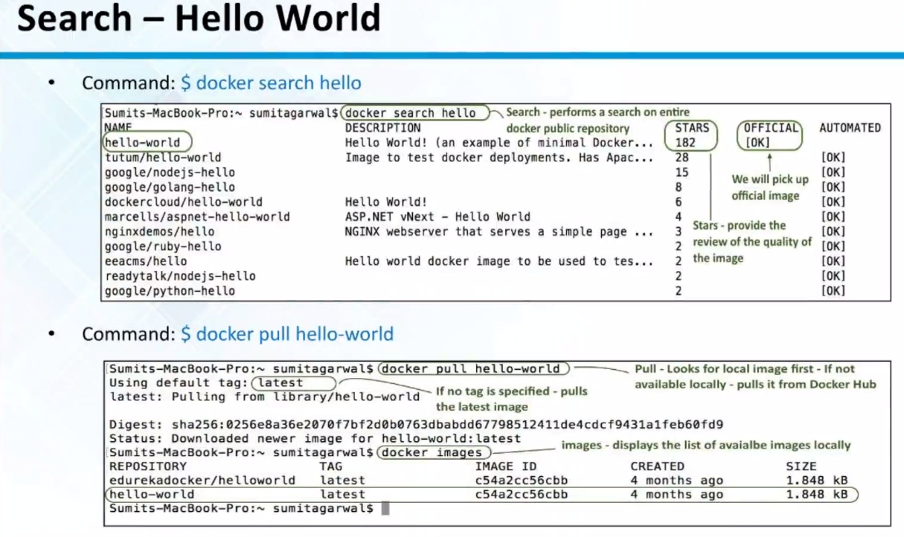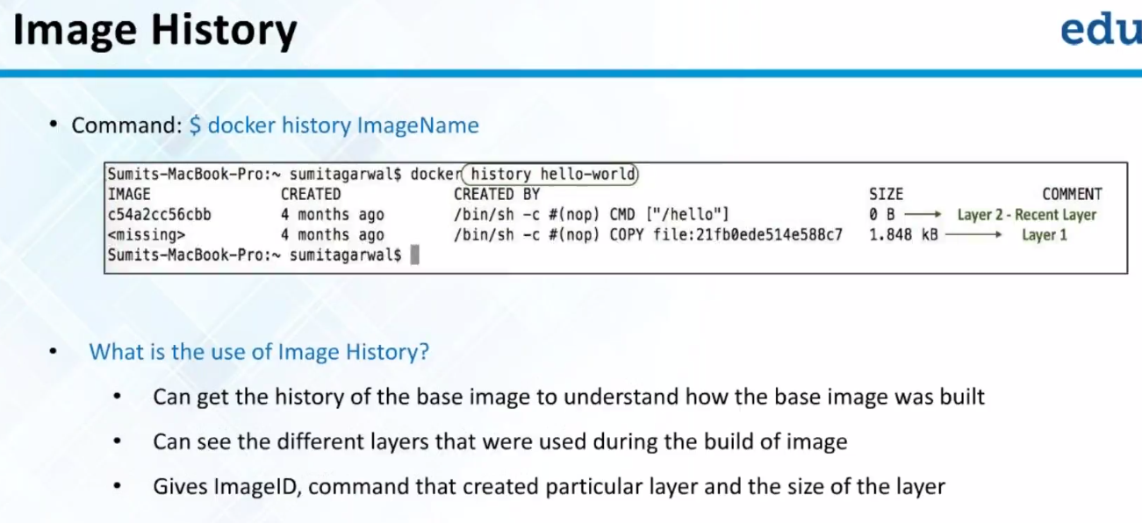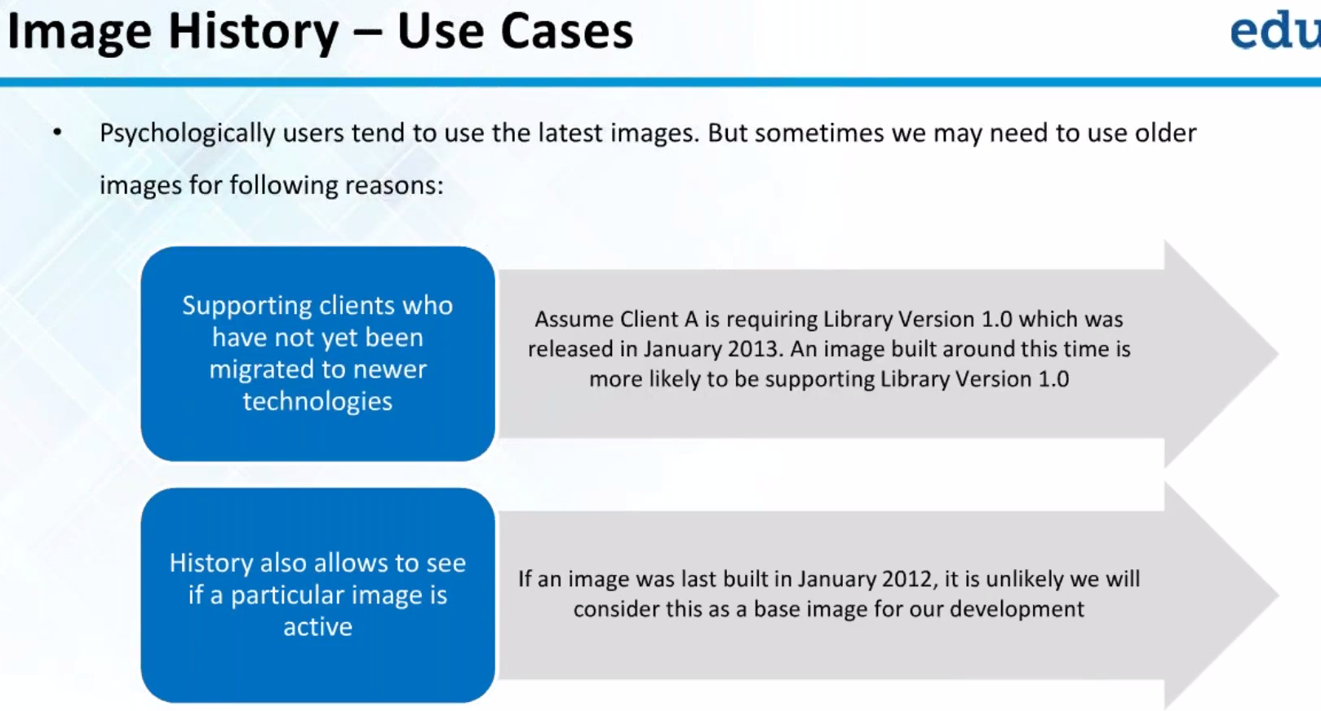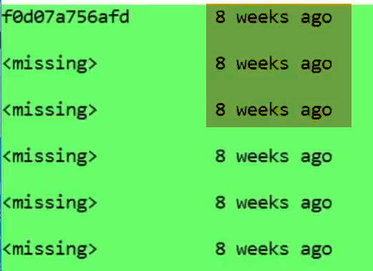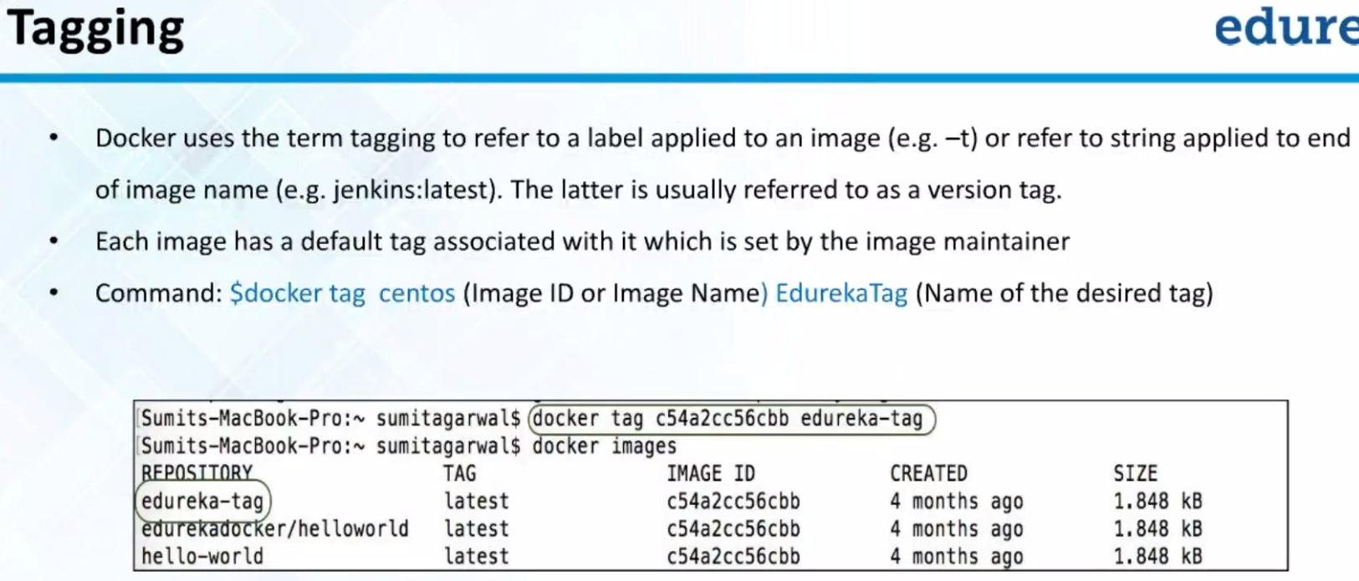

Namespace:

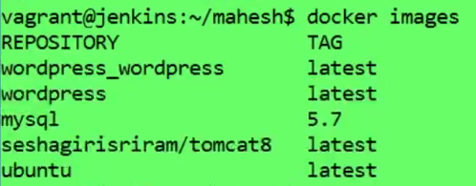

Certain Images names prefaced by name seshagiri/tomcat8.Some are not prefixed like Ubuntu.

This is what we call as namespace..

Use: Typically more than 1 person on dockerhub can have image called Ubuntu..

How to differentiate Ubuntu and seshagiri/tomcat8??

When no name prefixed is bad practice.. Implicit namespace called LIBRARY is there..

Official images doen’t begin with name..They are assumed to be in libraray namespace..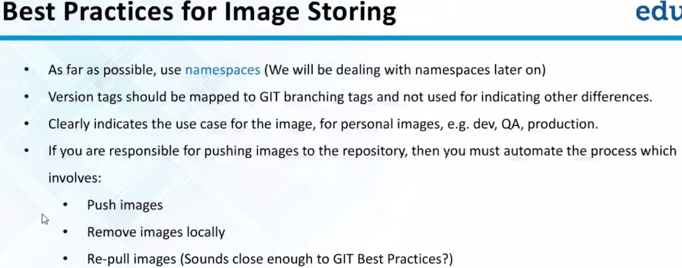

IIIlar to GIT floe: Take changes🡪 push to repo.. Git pull🡪 latest

Docker: Take image🡪 Push to repo..Pull back to get latest one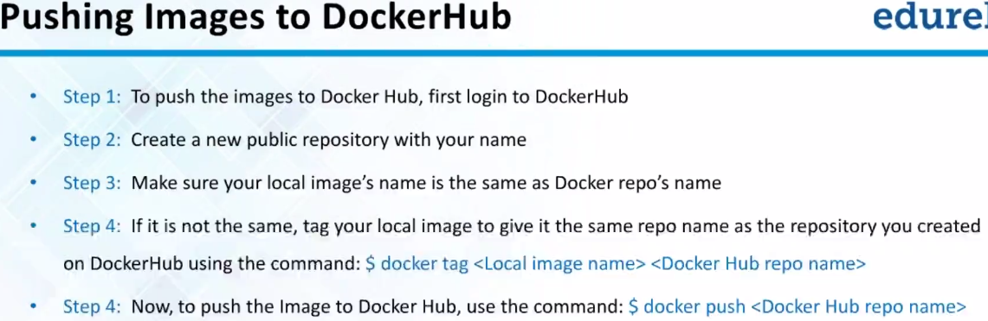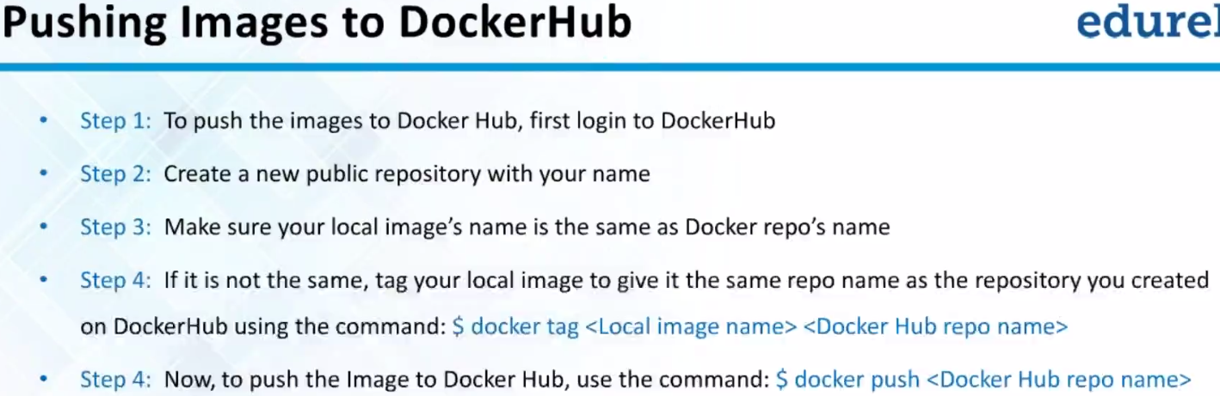

Make sure repo user name and namespace are same..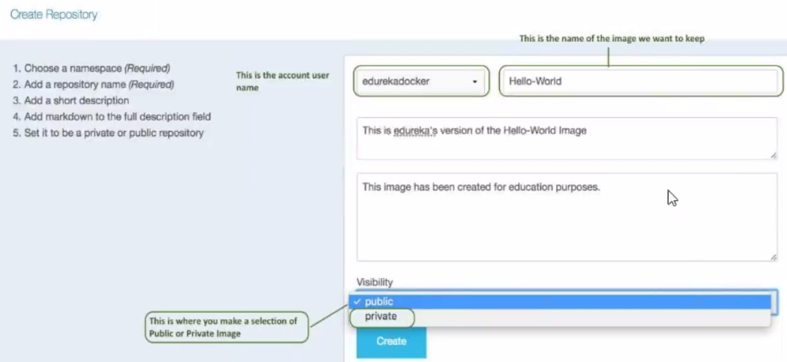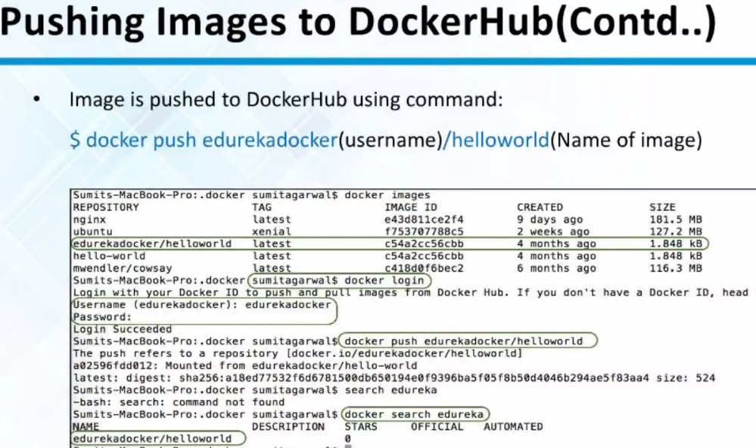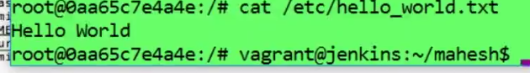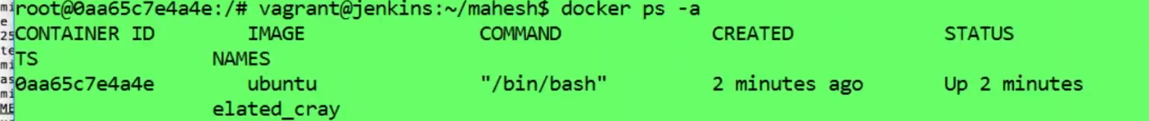

How do I know..Which image I’m goint to Commit??

Use image ID or image-tag

How to Switch b/w containers??

Not there…

We can use attach or exec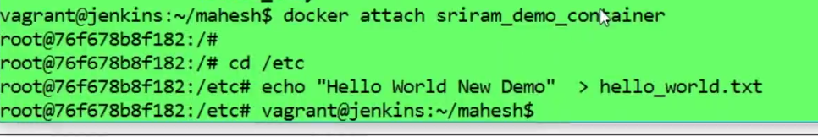

Don’t press CTRL+C or extis..container will exit..and changes will be lost..

USE CTRL+P CTRL+Q🡪 existed without stopping container.

It is not destroyed…Stopped